LAB # 06
Working with UML Diagrams in MS-VISIO

Introduction
Definition
- UML stands for Unified Modeling Language which is used in object oriented software engineering.
- It can be used to model an application structures, behavior and even business processes.
- There are 14 UML diagram types to help you model these behavior.
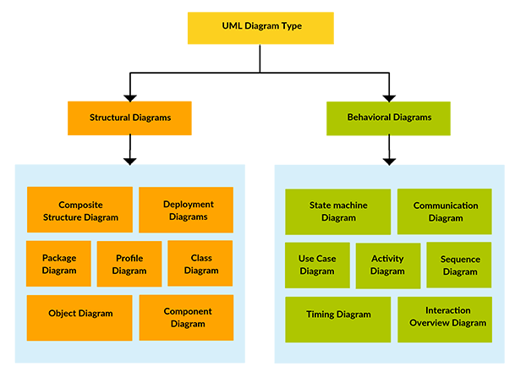
TYPES OF UML DIAGRAMS
- Structure diagrams show the things in a system being modeled. In a more technical term, they show different objects in a system.
- Behavioral diagrams shows what should happen in a system. They describe how the objects interact with each other to create a functioning system.

USECASE DIAGRAMS
Use case diagrams give a graphic overview of the actors involved in a system, different functions needed by those actors and how these different functions are interacted. You can easily identify the main actors involved and the main processes of the system.


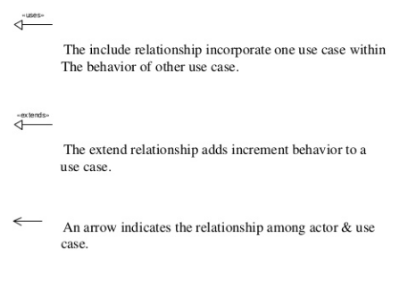

EXAMPLE
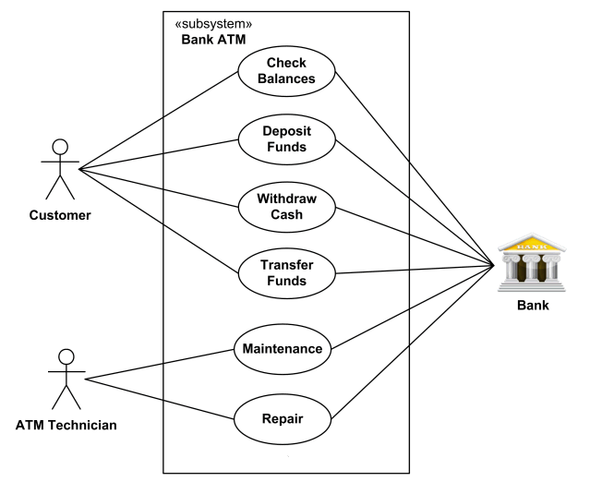

ACTIVITY DIAGRAM
Activity diagrams represent workflows in a graphical way. They can be used to describe business workflow or the operational workflow of any component in a system

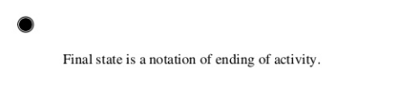

EXAMPLE
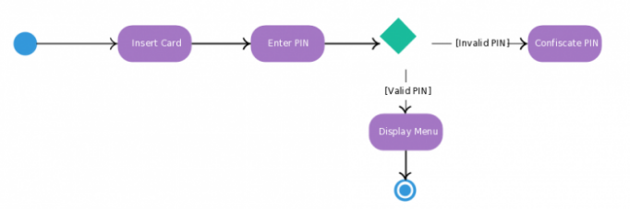

SEQUENCE DIAGRAM
Sequence diagrams, commonly used by developers, model the interactions between objects in a single use case. They illustrate how the different parts of a system interact with each other to carry out a function, and the order in which the interactions occur when a particular use case is executed. In simpler words, a sequence diagram shows different parts of a system work in a ‘sequence’ to get something done.
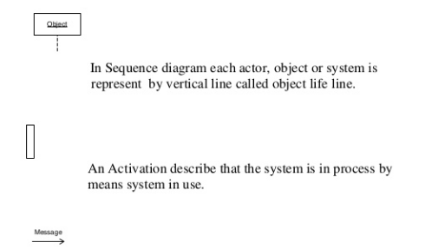

EXAMPLE
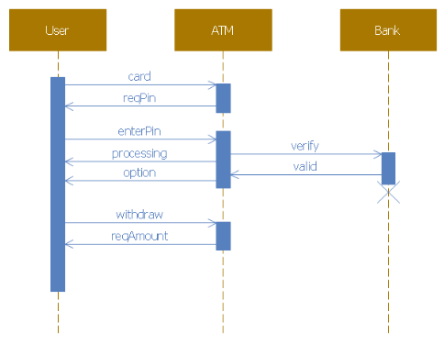

Lab Tasks
Draw these UML DIAGRAMS for Online Shopping System:
Task 1: Use case Diagram
Task 2: Activity Diagram
Task 3: Sequence Diagram

